**BANK LOAN ANALYSIS**

**Introduction**

In the modern financial ecosystem, data-driven decisions are crucial for managing credit risk, optimizing loan offerings, and enhancing borrower experiences. This project, **Bank Loan Analysis**, focuses on analyzing a large dataset of loan applications to understand borrower behavior, credit risk indicators, and loan performance metrics.

Using interactive dashboards and summary visualizations, this project offers deep insights into how loan applications vary by **employment length, home ownership, loan purpose, credit grade**, and **term duration**. Additionally, key performance indicators such as **average interest rate** and **debt-to-income (DTI)** ratios help assess financial risk and lending efficiency.

**Objective:**

* **Summarize Loan Metrics**:

Calculate total loan applications, fund amounts, and disbursed values.

Analyze interest rate trends and debt-to-income ratios.

* **Segment Loans by Demographics**:

Explore loan application trends by employment length, address (state), and home ownership.

Identify popular loan purposes such as **debt consolidation**, **home improvement**, and **credit card refinancing**.

* **Evaluate Loan Risk Factors**:

Compare loan grades and subgrades with associated interest rates.

Examine how loan duration (36 vs 60 months) impacts volume and risk.

* **Monitor Temporal Trends**:

Analyze loan issuance over time and its relation to credit quality and payment status (e.g., current, charged off).

* **Support Decision Making**:

Provide banks or lending institutions with a user-friendly summary for smarter lending strategies.

SQL PART

**Total Loan Applications**

SELECT COUNT(id) AS Total_Applications FROM bank_loan_data



**MTD Loan Applications**

SELECT COUNT(id) AS Total_Applications FROM bank_loan_data

WHERE MONTH(issue_date) = 12



**PMTD Loan Applications**  
SELECT COUNT(id) AS Total_Applications FROM bank_loan_data

WHERE MONTH(issue_date) = 11



**Total Funded Amount**

SELECT SUM(loan_amount) AS Total_Funded_Amount FROM bank_loan_data



**MTD Total Funded Amount**

SELECT SUM(loan_amount) AS Total_Funded_Amount FROM bank_loan_data

WHERE MONTH(issue_date) = 12



**PMTD Total Funded Amount**

SELECT SUM(loan_amount) AS Total_Funded_Amount FROM bank_loan_data

WHERE MONTH(issue_date) = 11



**Total Amount Received**

SELECT SUM(total_payment) AS Total_Amount_Collected FROM bank_loan_data



**MTD Total Amount Received**

SELECT SUM(total_payment) AS Total_Amount_Collected FROM bank_loan_data

WHERE MONTH(issue_date) = 12



**PMTD Total Amount Received**

SELECT SUM(total_payment) AS Total_Amount_Collected FROM bank_loan_data

WHERE MONTH(issue_date) = 11



**Average Interest Rate**

SELECT AVG(int_rate)*100 AS Avg_Int_Rate FROM bank_loan_data



**MTD Average Interest**

SELECT AVG(int_rate)*100 AS MTD_Avg_Int_Rate FROM bank_loan_data

WHERE MONTH(issue_date) = 12



**PMTD Average Interest**

SELECT AVG(int_rate)*100 AS PMTD_Avg_Int_Rate FROM bank_loan_data

WHERE MONTH(issue_date) = 11



**Avg DTI**

SELECT AVG(dti)*100 AS Avg_DTI FROM bank_loan_data



**MTD Avg DTI**

SELECT AVG(dti)*100 AS MTD_Avg_DTI FROM bank_loan_data

WHERE MONTH(issue_date) = 12



**PMTD Avg DTI**

SELECT AVG(dti)*100 AS PMTD_Avg_DTI FROM bank_loan_data

WHERE MONTH(issue_date) = 11



**GOOD LOAN ISSUED**

**Good Loan Percentage**

SELECT

    (COUNT(CASE WHEN loan_status = 'Fully Paid' OR loan_status = 'Current' THEN id END) * 100.0) /

COUNT(id) AS Good_Loan_Percentage

FROM bank_loan_data



**Good Loan Applications**

SELECT COUNT(id) AS Good_Loan_Applications FROM bank_loan_data

WHERE loan_status = 'Fully Paid' OR loan_status = 'Current'



**Good Loan Funded Amount**

SELECT SUM(loan_amount) AS Good_Loan_Funded_amount FROM bank_loan_data

WHERE loan_status = 'Fully Paid' OR loan_status = 'Current'



**Good Loan Amount Received**

SELECT SUM(total_payment) AS Good_Loan_amount_received FROM bank_loan_data

WHERE loan_status = 'Fully Paid' OR loan_status = 'Current'



**BAD LOAN ISSUED**

**Bad Loan Percentage**

SELECT

    (COUNT(CASE WHEN loan_status = 'Charged Off' THEN id END) * 100.0) /

COUNT(id) AS Bad_Loan_Percentage

FROM bank_loan_data



**Bad Loan Applications**

SELECT COUNT(id) AS Bad_Loan_Applications FROM bank_loan_data

WHERE loan_status = 'Charged Off'



**Bad Loan Funded Amount**

SELECT SUM(loan_amount) AS Bad_Loan_Funded_amount FROM bank_loan_data

WHERE loan_status = 'Charged Off'



**Bad Loan Amount Received**

SELECT SUM(total_payment) AS Bad_Loan_amount_received FROM bank_loan_data

WHERE loan_status = 'Charged Off'



**LOAN STATUS**

SELECT

        loan_status,

        COUNT(id) AS LoanCount,

        SUM(total_payment) AS Total_Amount_Received,

        SUM(loan_amount) AS Total_Funded_Amount,

        AVG(int_rate * 100) AS Interest_Rate,

        AVG(dti * 100) AS DTI

    FROM

        bank_loan_data

    GROUP BY

        loan_status

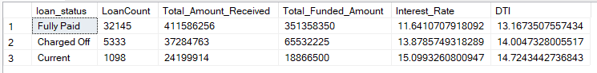

SELECT

loan_status,

SUM(total_payment) AS MTD_Total_Amount_Received,

SUM(loan_amount) AS MTD_Total_Funded_Amount

FROM bank_loan_data

WHERE MONTH(issue_date) = 12

GROUP BY loan_status

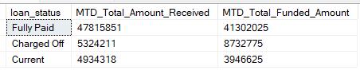

1. **BANK LOAN REPORT | OVERVIEW**

**MONTH**

SELECT

MONTH(issue_date) AS Month_Munber,

DATENAME(MONTH, issue_date) AS Month_name,

COUNT(id) AS Total_Loan_Applications,

SUM(loan_amount) AS Total_Funded_Amount,

SUM(total_payment) AS Total_Amount_Received

FROM bank_loan_data

GROUP BY MONTH(issue_date), DATENAME(MONTH, issue_date)

ORDER BY MONTH(issue_date)

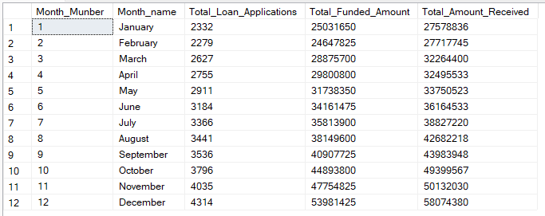

**STATE**

SELECT

address_state AS State,

COUNT(id) AS Total_Loan_Applications,

SUM(loan_amount) AS Total_Funded_Amount,

SUM(total_payment) AS Total_Amount_Received

FROM bank_loan_data

GROUP BY address_state

ORDER BY address_state

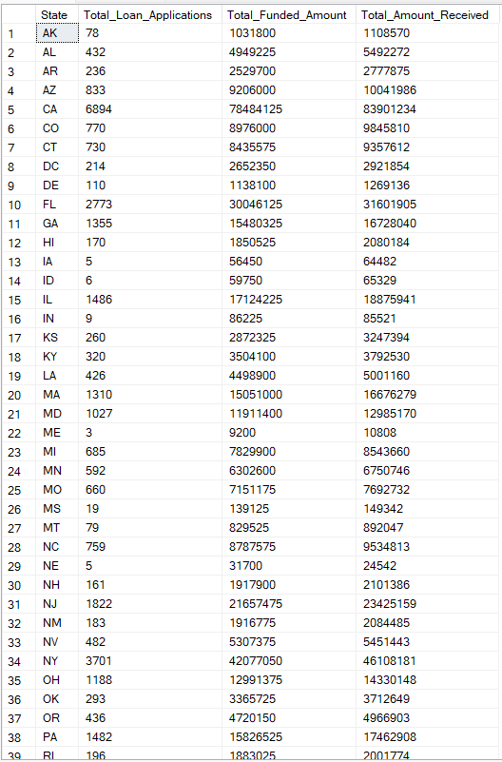

**TERM**

SELECT

term AS Term,

COUNT(id) AS Total_Loan_Applications,

SUM(loan_amount) AS Total_Funded_Amount,

SUM(total_payment) AS Total_Amount_Received

FROM bank_loan_data

GROUP BY term

ORDER BY term

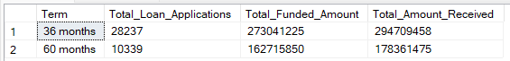

**EMPLOYEE LENGTH**

SELECT

emp_length AS Employee_Length,

COUNT(id) AS Total_Loan_Applications,

SUM(loan_amount) AS Total_Funded_Amount,

SUM(total_payment) AS Total_Amount_Received

FROM bank_loan_data

GROUP BY emp_length

ORDER BY emp_length

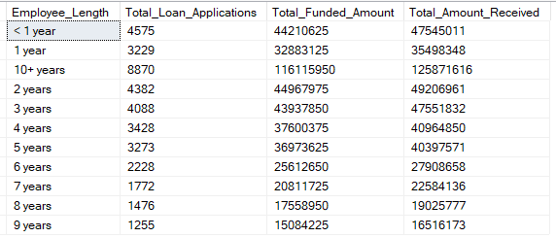

**PURPOSE**

SELECT

purpose AS PURPOSE,

COUNT(id) AS Total_Loan_Applications,

SUM(loan_amount) AS Total_Funded_Amount,

SUM(total_payment) AS Total_Amount_Received

FROM bank_loan_data

GROUP BY purpose

ORDER BY purpose

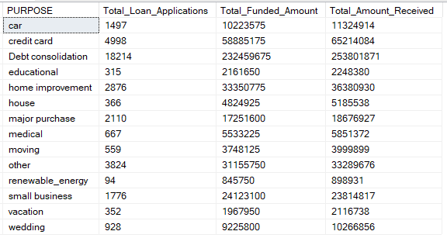

**HOME OWNERSHIP**

SELECT

home_ownership AS Home_Ownership,

COUNT(id) AS Total_Loan_Applications,

SUM(loan_amount) AS Total_Funded_Amount,

SUM(total_payment) AS Total_Amount_Received

FROM bank_loan_data

GROUP BY home_ownership

ORDER BY home_ownership

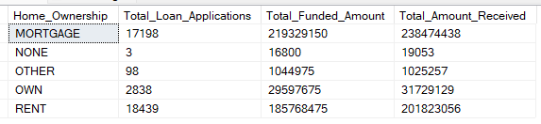

Graphs FOR POWER BI

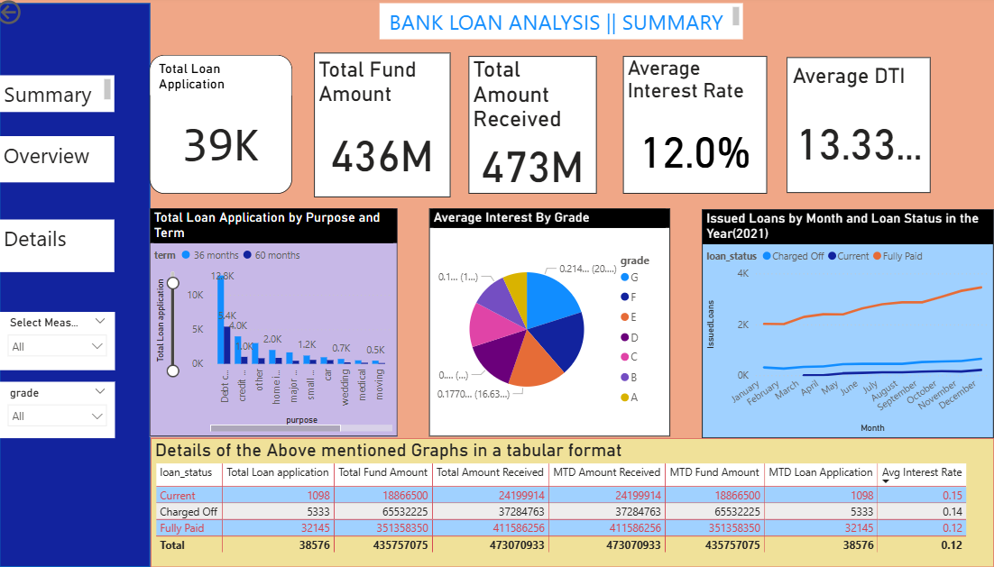

Figure 1: Details about this Project

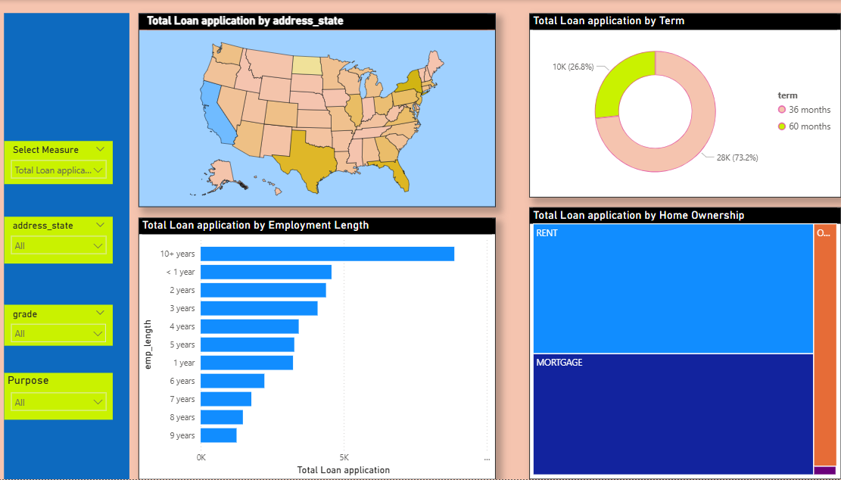

Figure2: Over View

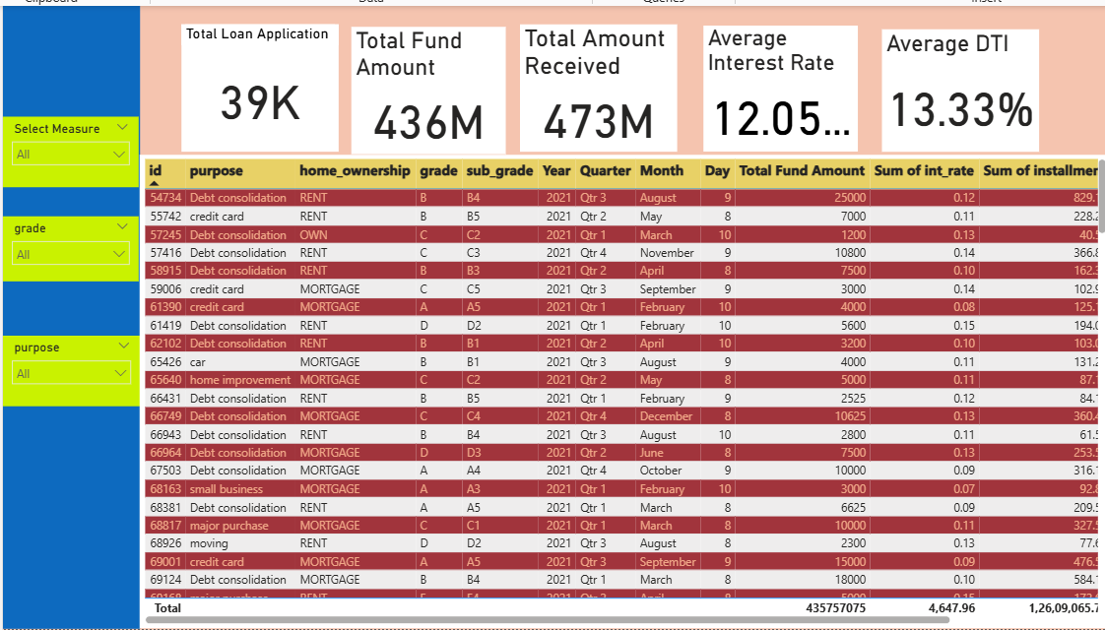

Figure3: Table showing varies details

Codes for this Project

**Total Loan Applications**

Total Loan application = COUNT(financial_loan[id])

ANSWER = 39K

* **Definition**: This is the number of people or entities who applied for a loan.
* **Economic Interpretation**:
* A high number (39,000) suggests **strong demand for credit**, which can indicate:
  + Growing consumer or business needs for financing (for education, housing, capital, etc.)
  + Positive economic activity or rising consumption.
  + However, in some contexts, it may also suggest **insufficient income or savings**, pushing more people to borrow.

**MTD Loan Applications**

MTD Loan Application = CALCULATE( TOTALMTD([Total Loan application], 'Date_Table'[Date]))

ANSWER=4.3K

* **Definition:**
* **MTD (Month-To-Date)** refers to the total loan applications received **from the start of the current month up to the current date**.It gives a **real-time snapshot** of how many applications have come in during the **current month** so far.
* This means **4,300 loan applications** have been submitted in the **current month so far**.
* **Economic Interpretation**:
* A lower or moderate MTD value (e.g., 4.3K) might suggest:
* Slower application rates this month — possibly due to:
* Seasonal dip, Tighter lending rules, Economic slowdown -- However, it could also reflect **incomplete data if the month isn't over yet**.
* MTD trends help banks **adjust marketing strategies or interest rates** mid-month

**PMTD Loan Applications**

PMTD LOAN APPLICATION = CALCULATE([Total Loan Application], DATESMTD(DATEADD('Date_Table'[Date],-1,MONTH)))

Mom Loan Application = ([MTD Loan Application] -[PMTD LOAN APPLICATION])/[PMTD LOAN APPLICATION]

ANSWER = 6.9K

* **Definition:**
* **PMTD** refers to the **number of loan applications** received from the **start to the same day of the previous month**. Used to **compare current month's performance against the previous month**.
* This indicates that **6,900 loan applications** were received during the **same time window last month**.
* **Economic Interpretation**:
* The **drop from 6.9K to 4.3K** suggests a **decline in loan demand** this month.
* This could be due to:

1. **Rising interest rates** or tightening credit conditions.
2. **Lower consumer confidence** or delayed borrowing decisions.
3. Policy changes affecting eligibility (e.g., income verification, DTI caps).
4. If this trend continues, banks may:
5. **Relax criteria** or offer **discounts** to boost applications.
6. **Shift focus to high-quality borrowers** to minimize risk.

**Total Funded Amount**

Total Fund Amount = SUM(financial_loan[loan_amount])

Answer: $ 436M

* **Definition**: This is the total amount of money requested or sanctioned in loan applications.
* Economic Reasons: **Interpretation**:
* ₹436 million represents a significant level of **capital mobilization**.
* This could reflect:
* Investment in business or infrastructure.
* Confidence in the financial system to provide credit.
* Potential stimulus to economic growth via credit expansion.

MTD Fund Amount = CALCULATE (TOTALMTD ([Total Fund Amount], 'Date_Table'[Date]))

ANSWER = $54.0M

* **Definition**: This is the total amount of money requested or sanctioned in loan applications.
* **Economic Interpretation**:
* ₹436 million represents a significant level of **capital mobilization**.
* This could reflect:
  + Investment in business or infrastructure.
  + Confidence in the financial system to provide credit.
  + Potential stimulus to economic growth via credit expansion.

**PMTD Fund Received**

PMTD Fund Received = CALCULATE([Total Fund Amount], DATESMTD(DATEADD('Date_Table'[Date],-1,MONTH)))

Mom Fund Received = ([MTD Fund Amount] -[PMTD Fund Received])/[PMTD Fund Received]

ANSWER: 13.0%

Definition:

**Average Interest Rate**

Avg Interest Rate = AVERAGE (financial_loan[int_rate])

ANSWER: 12.05%

* **Definition**: The average annual rate charged by lenders on loans.
* **Economic Interpretation**:
* A rate of 12.05% is relatively **high for personal or business loans**, indicating:
  + **Higher credit risk** among borrowers (may be due to weaker credit profiles).
  + **Tight monetary policy** or market-driven rates in developing economies.
  + Could also reduce the incentive to borrow unless returns on investment are higher.

**MTD Average Interest**

MTD Average Interest = CALCULATE(TOTALMTD([Avg Interest Rate], 'DTable'[Date]))

Answer: 12.4%

* **Definition:**
* **MTD (Month-To-Date) Average Interest** represents the average interest rate on all loans **approved or applied for since the start of the current month up to today.**
* **Economic Explanation:**
* A 12.4% MTD average interest indicates that **current lending rates are moderately high**, suggesting:
  + Banks may see **higher credit risk among recent applicants**, leading to increased rates.
  + Or, the institution might be operating in an environment of **tight monetary policy** or inflation, which raises borrowing costs.
* Tracking MTD interest helps lenders spot **early shifts in risk profiles or market rates**.

**PMTD Average Interest**

PMTD Average Interest = CALCULATE ([Avg Interest Rate], DATESMTD(DATEADD('Date_Table'[Date],-1,MONTH)))

Mom Average Interest = ([MTD Average Interest] -[PMTD Average Interest])/[PMTD Average Interest]

Answer:3.5%

* **Definition:**
* **PMTD (Previous Month-To-Date) Average Interest** is the average interest rate for loans **during the same time window in the previous month** (e.g., if today is the 15th, it considers the 1st–15th of last month).
* **Economic Explanation:**
* PMTD provides a **benchmark for comparison**, highlighting how average lending rates have changed relative to last month.
* If rates were lower last month (11.9%), it could mean:
  + **Increased perceived risk among borrowers this month**, leading lenders to hike rates.
  + Or market factors like central bank policy changes or inflation expectations pushing rates up

**Average DTI**

Average DTI = AVERAGE(financial_loan[dti])

Answer:13.33%

* **Definition**
* **Debt-to-Income Ratio (DTI)** is the percentage of a borrower's income that goes toward paying debts.
* **Economic Explanation:**
* A DTI of 13.33% implies that, on average, borrowers use **13.33% of their income to repay debt**.
* This is a **healthy and acceptable level**—most financial institutions consider DTIs under 36% as safe.
* It reflects: **Low credit stress**, **Greater repayment capacity** & **Stable borrower base**

**MTD Average DTI**

MTD Average DTI = CALCULATE(TOTALMTD([Average DTI], 'DTable'[Date]))

Answer: 13.7%

**Definition:**

* Measures the **average DTI of all loan applicants from the beginning of the current month to today**.

**Economic Explanation:**

* A slightly higher MTD DTI (13.7%) than the overall average (13.33%) may suggest:
  + A **slight increase in recent borrower indebtedness**
  + **Potential credit stress** rising in the current month
* Banks may **tighten lending criteria** if the trend continues, especially for riskier loan products.

PMTD Average DTI

PMTD Average DTI = CALCULATE ([Average DTI], DATESMTD(DATEADD('Date_Table'[Date],-1,MONTH)))

Mom Average DTI = ([MTD Average DTI] -[PMTD Average DTI])/[PMTD Average DTI]

Answer: 2.7%

* **Definition:**
* Measures the **relative percentage increase** in DTI from PMTD to MTD
* **Economic Explanation**
* A 2.7% increase indicates a **moderate rise in credit stress** among borrowers.
* If sustained, it could imply:
  + Deteriorating financial health of new applicants.
  + Need for **more rigorous credit checks**.
  + Possible signal for banks to **adjust interest rates or credit limits** proactively.

**Total Loan Application by Purpose and Term**

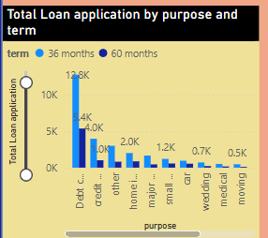

The graph titled "Total Loan Application by Purpose and Term" displays the distribution of loan applications based on their purpose and duration (either *36 months* or *60 months*). The most prominent observation is that *Debt Consolidation* dominates all categories with approximately **18.2K applications,** indicating that a large number of borrowers are using loans to *manage or refinance existing debts*, which reflects rising *credit stress* among individuals. There is a strong borrower preference for *36-month loans* across all categories, suggesting a desire to *repay debt faster* and avoid long-term interest burdens—highlighting a *conservative borrowing approach*. ***Credit Card* loans**, which likely aim to refinance high-interest card balances, are the second most common, pointing to increasing use of *unsecured credit*. Categories like *Home Improvement* and *Small Business* have moderate demand, indicating *moderate consumer confidence* and *entrepreneurial activity*, though the relatively low number of *business loans* may reflect *accessibility barriers or higher lending risk*. Other purposes such as *wedding, medical, and moving* have lower volumes, suggesting that they are either less prioritized or that individuals avoid borrowing for non-essential purposes during uncertain economic conditions. Overall, the graph reveals patterns of *debt restructuring, short-term borrowing preferences,* and the *financial behavior of modern loan applicants*.

**Average Interest By Grade**

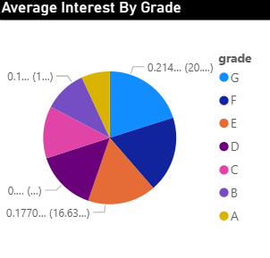

Figure2: A Pie Chart showing the Average Interest by grade

**Graph Interpretation:** Each pie slice corresponds to a credit **grade (A to G)**:

* **Grade G**: Largest slice (~21.4%) — highest average interest rate.
* **Grade B**: Second largest (~17.7%).
* **Grades D, C, E**: Moderate interest rates.
* **Grade A**: Smallest slice (~10%) — lowest average interest rate.
* **Grades F, E**: Smaller than G but larger than A.

The pie chart titled "Average Interest By Grade " illustrates how interest rates vary across different borrower credit grades (A to G). It shows that borrowers with Grade G face the highest average interest rate (around 21.4%), while those with Grade A enjoy the lowest (approximately 10%).. This distribution reflects how lenders assess credit risk—offering lower rates to highly creditworthy borrowers and higher rates to those deemed riskier. The size of each slice corresponds to the average interest rate per grade, indicating the increasing cost of borrowing as the perceived risk of default grows**.**

Economically, this pattern is a result of risk-based pricing, where lenders charge interest in proportion to the borrower’s default probability. Grade A borrowers typically have strong repayment histories, stable income, and low existing debt, so they are rewarded with low interest rates. In contrast, Grade G borrowers often have poor credit histories or unstable financial conditions, prompting lenders to charge higher rates as a risk premium. This pricing model also accounts for moral hazard and adverse selection—charging more to discourage high-risk borrowers from defaulting and to ensure the loan remains profitable even if a small fraction of borrowers fail to repay.

**Issued Loans by Month and Loan Status**

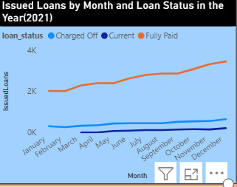

Figure 3: Issued Loans by Month and Loan Status

The line graph titled **"Issued Loans by Month and Loan Status"** tracks the number of loans issued each month, segmented by their final status—**Fully Paid**, **Current**, or **Charged Off**. Throughout the year, the orange line (Fully Paid loans) consistently rises, peaking at over 4,000 by December. The light blue line (Current loans) shows a gradual increase, while the dark blue line (Charged Off loans) remains the lowest, increasing slightly but staying under 1,000. This suggests that most loans are successfully repaid, and a smaller proportion is either still in repayment or has defaulted.

Economically, the upward trend in fully paid loans suggests **improving borrower credit behavior** or favorable **economic conditions**, such as stable employment and income levels, enabling borrowers to meet their repayment obligations. The relatively low and stable number of charged-off loans implies effective **risk assessment and underwriting** by lenders, who are likely approving loans to more creditworthy applicants. Additionally, the gradual increase in current loans indicates a **growing demand for credit**, potentially reflecting **seasonal consumption patterns**, business cycles, or improved borrower confidence. These patterns highlight the importance of credit monitoring and dynamic lending strategies based on macroeconomic trends and borrower profiles.

Tabular Format

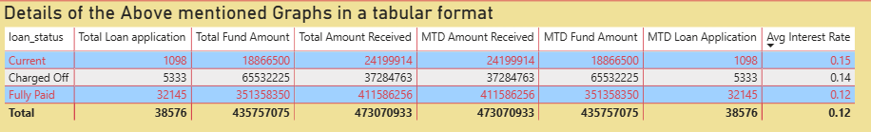Table1: The table summarizes the loan data.

It breaking it down by **loan status**—Current, Charged Off, and Fully Paid—across key financial metrics. The majority of loans (32,145 out of 38,576 applications) fall under the **"Fully Paid"** category, with a total fund amount of over **35 million** and the **lowest average interest rate of 12%**. On the other hand, **"Charged Off"** loans (i.e., defaults) make up 5,333 applications with a significantly **higher average interest rate of 14%**. **"Current"** loans, which are still being repaid, are relatively few (1,098) but bear the **highest interest rate at 15%**.

Economically, this trend reveals how **interest rates reflect risk assessment**. Lenders impose **higher rates on loans with greater risk of default** (as seen in "Current" and "Charged Off" categories), which aligns with the principle of **risk-based pricing**. Interestingly, despite being charged higher interest, many of these high-risk loans end up being **charged off**, indicating that the additional interest wasn't always sufficient to cover the risk. Meanwhile, the lower interest rate for fully paid loans suggests that **more creditworthy borrowers**—those with better repayment capability—are rewarded with cheaper credit and are more likely to fulfill repayment obligations. This data showcases the critical balance financial institutions maintain between **risk management** and **profitability**, driven by borrower behavior and economic risk assessment.

**Total Loan Application by address state**

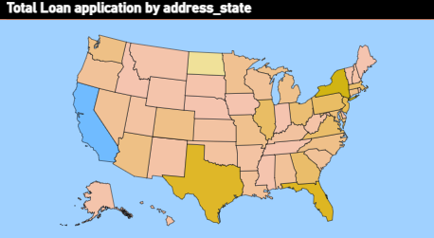 Figure 4: Total Loan Application by address state

The map titled **"Total Loan Application by Address_State"** displays the geographic distribution of loan applications across the United States. States like **California, Texas, Florida, and New York** are shaded in **darker colors**, indicating a **higher volume of loan applications**, while lighter-shaded states like **Montana, Wyoming, and North Dakota** show **fewer applications**. This color gradient effectively highlights the disparity in loan demand by state.

Economically, higher loan applications in states like California, Texas, and Florida can be attributed to their **larger populations**, **urbanization**, and **diverse economic activities**, which naturally generate a higher demand for credit—both for personal consumption and business investment. These states also tend to have higher **costs of living**, pushing individuals to rely more on loans to manage expenses like education, healthcare, or housing. Conversely, states with fewer applications are often **rural, less densely populated**, and may have **limited access to financial institutions** or **lower income variability**, reducing the perceived need or eligibility for credit. This regional variation reflects not only **demographic and economic differences** but also **financial literacy**, **access to banking**, and **state-level regulatory environments** that influence borrowing behaviour.

**Total Loan Application By Term**

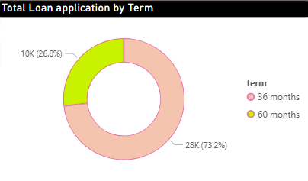

Figure 5: Total Loan Application by Term

| **Loan Term** | **Number of Applications** | **Percentage of Total** |
| --- | --- | --- |
| 36 months | 28,237 | 73.2% |
| 60 months | 10,339 | 26.8% |

The visualization shows that a significant majority of loan applicants, about **73.2%**, opted for a **36-month term**, while only **26.8%** chose a **60-month term**. This trend reflects a common economic behavior where borrowers prefer shorter-term loans to minimize the total interest paid over the loan period. Since shorter durations generally have lower overall interest costs, financially aware individuals are more inclined toward them if they can afford higher monthly payments. Moreover, those with stable income sources or better credit profiles are more likely to be approved for shorter terms, as lenders consider them lower risk.

Additionally, the preference for 36-month loans could be influenced by the size and purpose of the loan. Shorter terms are often suitable for smaller loan amounts typically used for personal or emergency needs, which don’t require long repayment periods. There may also be psychological and behavioural reasons behind this preference—many borrowers prefer to become debt-free quickly and avoid the long-term burden of repayment. From the lender’s perspective, promoting 36-month terms is also beneficial, as they offer quicker cash recovery and lower default risk. This alignment of borrower and lender interests likely drives the dominance of shorter loan terms in the application data.

Total Loan Application By Employment Length

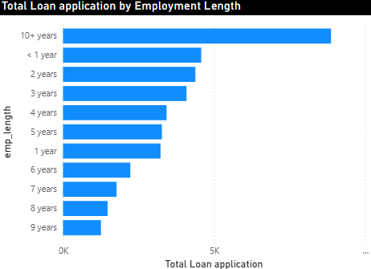 Figure 6: Total Loan Application By Employment Length

The bar chart titled **“Total Loan Application by Employment Length”** shows that individuals with **10+ years of employment experience** have the highest number of loan applications, followed by those with **less than 1 year** and **2–3 years**. This suggests that both long-term and newly employed individuals are active in the loan market, but for different economic reasons.

|  |  |
| --- | --- |
| Employment Length | Approximate Loan Applications |
| 10+ years | ~5,200 |
| < 1 year | ~3,800 |
| 2 years | ~3,600 |
| 3 years | ~3,400 |
| 4 years | ~3,200 |
| 5 years | ~3,000 |
| 1 year | ~2,800 |
| 6 years | ~2,000 |
| 7 years | ~1,700 |
| 8 years | ~1,500 |
| 9 years | ~1,300 |

Table 2: This table shows Total Loan Application By Employment Length

The ones with **10+ years of experience** are likely seen as **financially stable and low-risk borrowers**, making them more eligible and confident to apply for loans. Lenders typically prefer applicants with a long employment history as it signals job security and a steady income, reducing the risk of default.

On the other hand, the relatively high loan application volume among individuals with **less than 1 year of experience** could be attributed to **early financial needs**, such as setting up a household, purchasing a vehicle, or paying off education-related expenses. These borrowers may rely on credit to build their financial base despite limited work history. However, the lower number of applications among those with 6–9 years of experience could reflect a transitional phase where individuals may already have active loans or are more cautious about taking on new debt. Overall, employment length plays a key role in both the **perceived creditworthiness by lenders** and the **financial behavior of borrowers**, influencing loan application trends.

**Total Loan application by Home Ownership**

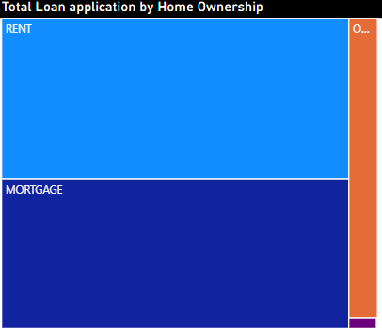Figure 7: The tree map shows **“Total Loan Application by Home Ownership”**

| **Home Ownership Status** | **Approximate %** | **Remarks** |
| --- | --- | --- |
| **RENT** | ~38–40% | Largest segment |
| **MORTGAGE** | ~38–40% | Very close to RENT |
| **OWN** | ~18–20% | Smaller but significant share |
| **OTHER** | ~2% | Minor segment |
| **NONE/Unknown** | ~0.5% or less | Tiny visible slice |

Table 3: **Data distribution** from the treemap titled **"Total Loan application by Home Ownership"** based on the visible area proportions

The tree map titled **“Total Loan Application by Home Ownership”** shows that the majority of loan applications come from individuals who **rent** or have a **mortgage**, while a very small proportion comes from those who **own their home outright** or fall into the “Other” category. This distribution provides insight into borrower behaviour and economic factors influencing the demand for credit.

Economically, renters and mortgage holders are more likely to **need external financing** to meet their financial obligations or aspirations. Renters typically have **lower accumulated wealth** and may use loans for daily needs, emergencies, or asset-building (like buying a car or funding education). Mortgage holders, despite owning homes, often have ongoing debt and may seek **personal loans to consolidate debts**, cover home-related expenses, or improve liquidity. In contrast, individuals who **own homes outright** tend to be **more financially stable**, with **greater asset security and less reliance on credit**, leading to fewer loan applications. This pattern underscores how **home ownership status influences credit demand**, reflecting both financial capacity and life-stage borrowing behaviour.

**Conclusion**

This comprehensive loan analysis reveals key behavioural and economic patterns among borrowers that can significantly inform lending strategies. The data shows a strong preference for **shorter-term loans (36 months)**, suggesting borrowers are conscious of **interest cost savings** and prefer **quick debt clearance**. **Debt consolidation and credit card refinancing** dominate loan purposes, indicating that many borrowers are attempting to manage existing liabilities—an indirect sign of **rising personal debt levels** or credit stress.

From a demographic perspective, the majority of loan applications come from individuals who either **rent or have a mortgage**, with those who **own homes outright** forming a small minority. This suggests that people with ongoing financial obligations are more likely to rely on credit. Additionally, employment length plays a significant role: both **long-term employees (10+ years)** and **new entrants (<1 year)** are active loan seekers, though for different reasons—stability vs. start-up needs.

Overall, the findings highlight that borrower behaviour is deeply influenced by **economic conditions, life stage, and credit access**. Lenders must tailor their strategies—offering competitive terms to reliable borrowers while tightening risk controls for high-risk segments. Monitoring interest rate trends, employment stability, and loan purpose segmentation is essential for sustainable and profitable lending operations.